Two’s Town News!
By: Ms. Phuong & Ms. Ishita

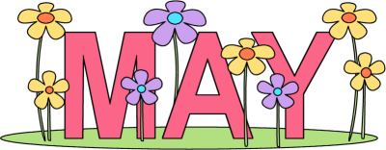

Our Two’s Town friends enjoyed the month of April! It was a very special time for our friends, because we celebrated “Week of the Young Child”. During this week, we talked about why we are all special and unique in our own ways. They also worked very hard on some very beautiful art projects for their mommies and daddies. The children really enjoyed making all these wonderful projects. We also had a fun movie and pajama day, made dirt cups for Artsy Thursday and had a blast for our Egg Hunt.
The Month of May is going to be very busy for our friends. May will be the last academic month of the school year, and we are busy preparing for our fun filled summer camp. We are excited to show our school spirit during spirit week!
We will continue to review our shapes, letters, colors, alphabet recognition and much more. This month we will focus a lot on our fine motor skills such as; lacing, cutting, beading, tearing, tracing, and our 3-finger pencil grasp. Please practice these skills at home.

Important Dates:
- May 11^{th:} Earthquake Drill
- May 14th: Movie Day
- May 17th- May 21st: School Spirit Week
- May 26^{th:} Fire Drill
- May 28th: Last Day of the Academic School Year

